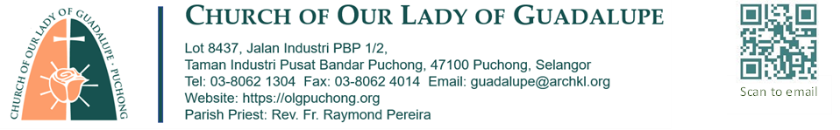
APPLICATION FOR BAPTISM – INFANT/CHILD
INFANT/CHILD PARTICULARS
NAME (as in BC/NRIC): …………………………………………………………………………………………………………………………….……..
BC/NRIC NO: …………………………………………………………………………………. SEX: M | F (circle where applicable)
DATE OF BIRTH : …………………..…….…….. PLACE OF BIRTH : ……………………………….………………………..………………
PARENTS PARTICULARS
Father : ………………………………………………………………………………………………. Religion: …………………………………….…..
Mother : ………………………………………………………………………………………..….. Religion: ………………………………….……..
Address :……………………………………………………………………………………………………………………………….……………….…………
…………………………………………………………………………………………………………………………………………………….……..
Contact : Home : ………………………… Office :……………………………… H/Phone :…………….…….….………….…..
Parent marriage Solemnized: Church/Chapel of ……………………………………………………………………………….……….……
at……………………………………………………………………………………………………….. on…………………………………………….…….
GODPARENTS PARTICULARS
God Father (Christian name): …………………………………………………………………………………………………………………………
God Mother (Christian name): ……………………………………………………………………………………………………………………….
SIGNATURE
Signature of Applicant: ………………………………………. State name if not parents ……………………………..…………
Signature of BEC Coordinator: ……………………………………… Zone: .…..….BEC name:…………………..………………….…….
Note: This form is to be returned to the office 1 week before the date of baptism. A fee of RM25.00 will be
collected for Baptismal candle and certificate. The required documents are as follows;
- Photocopy of infant’s birth certificate or child’s NRIC
- Photocopy of Godparents NRIC
CELEBRATION OF THE SACRAMENT OF BAPTISM
Baptism name: ……………………………………………………………..will be baptized at Church of Our Lady of Guadalupe
On: …………………………………………………………………..………. Time: ………………………………………………………………………
Minister: …………………………………………………………………….……………………………………………………………………………..…….
Briefing on: ………………………………………..……………………… Time: ………………………………………………………………………

